What is Office Communicator R2?

Office Communicator (OC) R2 is the next version of OC. In addition to standard features such as secure instant messaging, integrated Presence and OC-to-OC calling, OCR2 provides new functionality enhancements including:

- Desktop sharing: You can share, review and work on deliverables with the click of a button. Share control of your PC so that other IM conversation participants can add to or edit a deliverable regardless of location.
- Current Conversations: When you have one or more active conversations, a new group titled Current Conversations appears at the top of your Contact List. You can use this group to quickly scan your active conversations.
- Enhanced IM interface: In Conversation windows, users IM's are separated by different background colors, this is especially helpful when there are more than 2 active participants in an IM conference.
Find and Add Contacts:
To find a contact, type the person’s name in the Search box. You can contact the person directly from the Search Results or drag someone you contact frequently into your Contact List. It is recommended that you only add contacts you communicate with daily.

Note: You may not be able to search for Accenture contacts immediately after installing OCR2 as it takes some time for the Accenture Directory to download.
OCR2 Basics:
Change Your Presence Status:
Your Presence status will update
automatically based on your Outlook
calendar and your activity in OCR2 (In a call,
In a meeting, etc.). From the Presence bubble
drop-down menu you can also manually
update your Presence status, but will
have to reset it if you choose “Be Right Back”
or “Do Not Disturb”.
reset it .

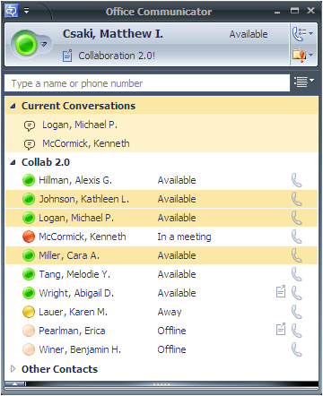
Set Your Location:
Click your Presence bubble,
select Current Location from the
menu, and then select a location
(home or office) or create a
customized location.

Contact Card:
Click the contact’s Presence bubble to view their
Contact Card. The amount of information on the Contact Card is controlled by the Access
Level the contact has
assigned you.
Note: See other side for
Access Level information.

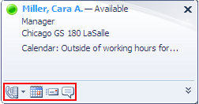

Contact Card options:
Call, schedule meeting, email, or IM

Contact Card communication options:
Call, schedule a meeting, e-mail, or IM with the contact.

Call a Contact:
Click the phone icon next to the contact.
2) Click the Presence bubble to see a person’s Contact Card and availability.

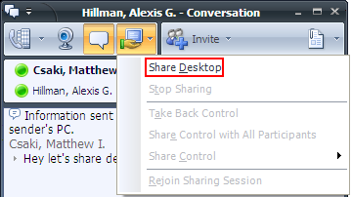
Share Your Desktop:

In OCR2, you can share your desktop with other participants. You can also share control so that others can provide mouse and keyboard input on your desktop.
Share your desktop
- From a Conversation window, click the Sharing icon to share your desktop.
- Select Share Desktop.
Share control
- After you select the Share Desktop option, a drop down menu in the top middle of your screen will appear.
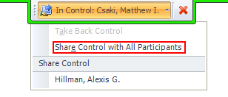
- You may select Share Control with All Participants if you want everyone to have control or select a contact under Share Control if you only want certain participants to have control of your PC.

Escalate an IM to a video call*:
Plug in your webcam and click the video icon during an IM conversation. *Video not available in all locations.
Escalate an IM to an audio call:
Click the phone icon during an IM conversation.
Current Conversations group:
You can use this group to quickly scan your active conversations.

Add additional contacts to an IM, audio or video conversation:
Drag additional names into the Conversation window.
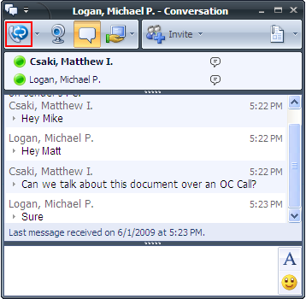

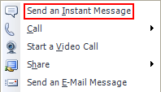
Send an IM:
Double-click a contact. To send a group IM, hold the CTRL key, select multiple contacts, right click, and select Send an Instant Message.

Enhanced IM interface:
Users IM's are separated by different background colors

Communicate with External Contacts:

Windows Messenger/MSN, AIM, and Yahoo Contacts:
To communicate with these contacts use one of the options below:
- Enter the contact's IM address in the OCR2 Search box, following the IM Address Format Guidelines below. Drag the contact from the OCR2 Search Results to your Contact List.
  - A contact import tool is also available if you wish to import a list of contacts into OCR2.
-OR-
- Add the contact’s IM Address to their Outlook Contact entry, following the IM Address Format Guidelines below. Then, find the contact with the OCR2 Search box and add them to your Contact List.
  - This method allows you to maintain one single entry for the contact, integrating their e-mail address, IM address and phone number(s).

IM Address Format Guidelines
AIM Yahoo
- userid@aol.com - userid@yahoo.com

Windows Messenger/MSN
- Standard Windows Messenger/MSN contacts: userid@hotmail.com or userid@live.com.
- Contacts using an address ending in a domain other than hotmail.com or live.com must be entered as
userid(domain.com)@msn.com - e.g. john.doe(gmail.com)@msn.com.
Other External Contacts:
Accenture has the ability to federate (formally associate) with other organizations that have also deployed OC. To see a list of federated organizations click here and communicate with federated contacts by searching for them using their e-mail address.

Customize Access Levels:

2a) Change Your Presence Status:
Your Presence status will update automatically based on your Outlook calendar and your activity in OC (In a call, In a meeting, etc.). From the Presence drop-down menu you can also manually update your Presence status.

2b) Set Your Location:
Click your Presence bubble, select Current Location from the menu, and then select a location (home or office) or create a customized location.

The Access Level you assign to a contact controls which aspects of your Presence information they see.

Presence Information | Block | Public | Company | Team | Personal
Presence |  | X | X | X | X
Display Name | X | X | X | X | X
E-mail Address | X | X | X | X | X
Work Phone* |  |  | X | X | X
Mobile Phone* |  |  |  | X | X
Home Phone |  |  |  |  | X
Meeting Subject/ Location |  |  |  | X
*Information published on your Accenture People page will be available to all Accenture people, regardless of the Access Level you have assigned to them.

Switch to Access Levels View:
Click the Change View button located to the right of the Search box, and select Access Levels. Your contacts will display according to their Access Level.
Transfer an incoming
call to another person
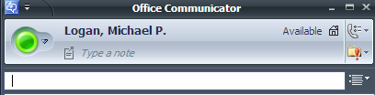
Change View button
Put a call on hold

End a call

Change a Person’s Access Level:
To edit a person’s Access Level, right-click the contact’s name in your Contact List, click Change Level of Access and then select a level from the options shown in the table (Block, Public, Company, Team, Personal). From the Access Levels view, you can also click and drag a contact from one Access Level to another.

Create a List of Contacts Who Can Interrupt You:
All contacts added to the Team Access Level have permission to interrupt you when your Presence status is set to Do Not Disturb.

Audio Setup:

Ensure your headset is configured using the software instructions provided. You should also run the Setup Audio Tuning Wizard to test and/or adjust your microphone and speakers. Click the Menu button in the OCR2 title bar and select Tools>Setup Audio and Video.

Audio Calls:

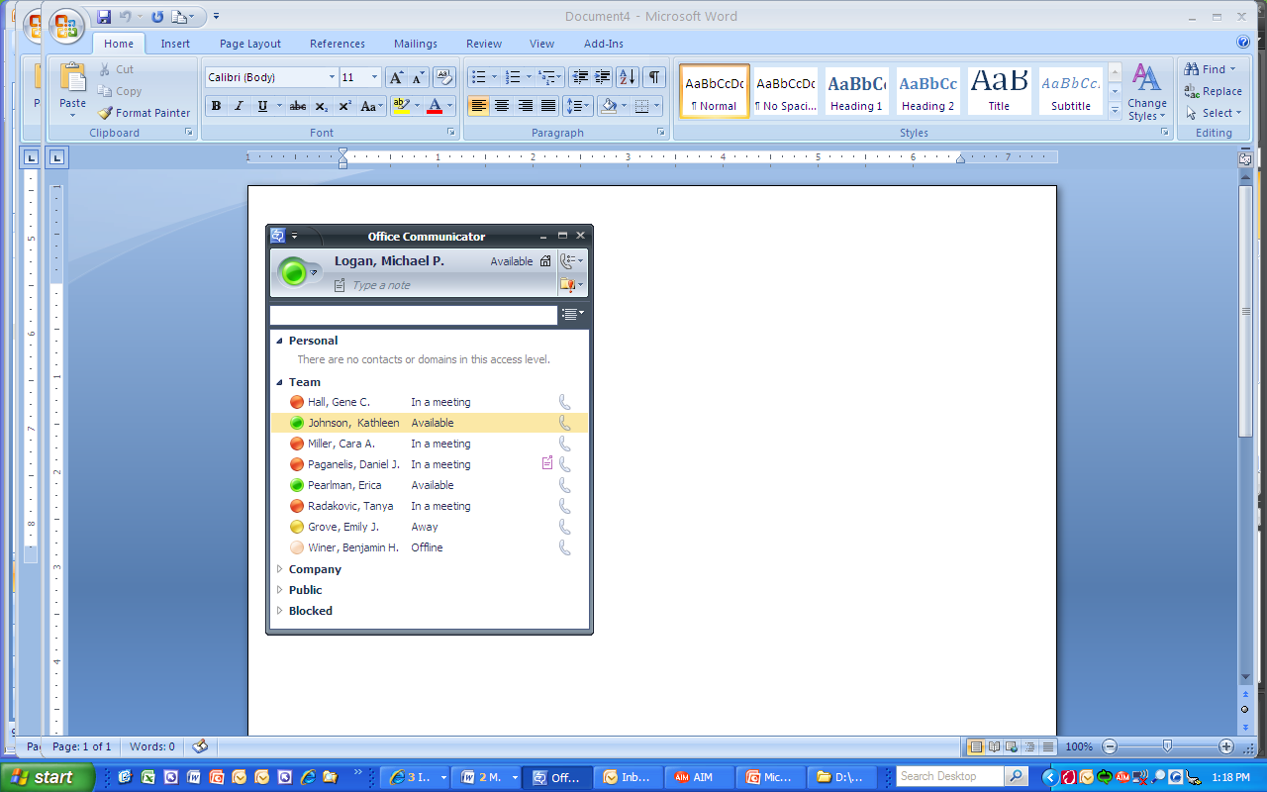
Peer to Peer Audio Calls:
Make an Audio Call:
In the Contact List, click the contact’s Call button.

Answer an Audio Call:
In the call invitation alert that appears in the bottom right of your computer screen, click the left pane.
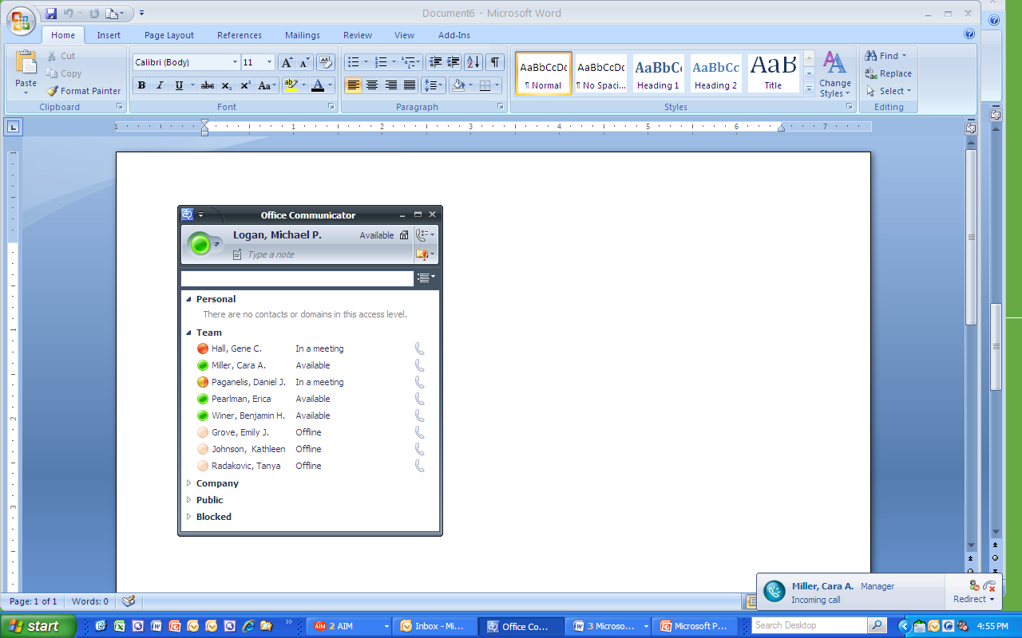

Audio Conference Calls:

You can use OCR2 to hold informal audio conferences with 100 participants. Note: the quality of user’s networks will affect the quality of the call.

Initiate an Audio Conference with Multiple Contacts:
Hold the CTRL key and select the contacts that you want to call. Right-click the last contact, and then select Start a Conference Call> Communicator from the menu.

During a Conference:
Invite Others to an Audio Conference:
Drag and drop the additional contact(s) from your OCR2 Contact List to the Conversation window.

Make a Participant a Conference Leader:
If you are the conference leader, you can make another person the leader. In the conference roster, right-click a participant and select Make Leader.

Mute a Participant as a conference leader:
In the conference roster, right-click the person you want to mute and then click Mute.

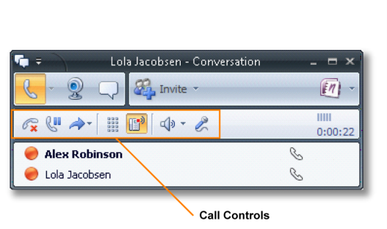
Call Controls:
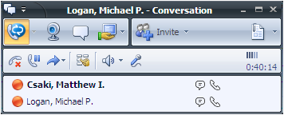
Mute speaker or adjust speaker volume

Mute microphone

Display dial pad

